**Assignment 1**

**Advanced Statistics (one-way ANOVA, Two-way ANOVA, ANCOVA and Regression Analysis)**

**Question 1:**

A marketing Researcher has conducted an experiment to test the effects of different print ad copy elements on attitude toward the product and intention to buy. The design of the experiment was a simple 2×2 balanced design (with 25 subjects in each cell). The first factor involved either the inclusion (or exclusion) of a competitive claim (i.e. our product is superior to other available products on a particular dimension). The second factor involved either the inclusion (or exclusion) of a uniqueness claim (i.e., our product is unlike any other available product). Thus, 25 subjects saw the basic print ad (without either claim), 25 subjects saw basic ad plus competitive claim, 25 subjects saw the basic ad plus uniqueness claim and 25 subjects saw the basic ad plus both claims. The following four response measures were taken:

Y­1 How much do you like this product? (from “Not at all” to “Very Much”)

Y2 I like this product (from “Strongly Disagree” to “Strongly agree”)

Y­3 I would buy this product (from “Strongly Disagree” to “Strongly agree”)

Y4 What is the likelihood you would buy this product? (stated probability)

All four items above are measured on a scale of 1 to 100. The data are available in the file AD_CLAIM_TEST. Analyze the data from the experiment and answer the following questions.

1. Which of the experimental treatments if any is significant at the 0.05 level for each of the four outcome variables Y­1, Y­2, Y­3, Y­4. Conduct Individual one –way Analysis of variance. State the hypothesis (null and alternate), test for assumptions, analyze and report your results
2. Test for interaction effects for each of the four outcome variables.
3. How would you test by taking into account simultaneously all these variables?
4. Now do the above analysis using regression approach. Report your results.

**Question 2**

Ofir and Simonson (2001)conducted several experiments investigating the effect of “expecting to evaluate” on ratings of product quality. They found that in a variety of situations, consumers are more critical (and provide ore negative ratings) when they are told in advance that they will be asked to provide an evaluation after they have experienced a product or service.

We now consider a subset of the data collected by Ofir and Simonson in one of their studies. A group of 201 subjects was asked to read an article that “appeared in the first issue of a new magazine” and all subjects were told that “we will ask for your evaluation of the writing quality of the magazine based on the article”. Thus all subjects expect to evaluate the article after reading it. For this group there were two experimental treatments: the quality of the article (high, low) and expectations about the quality of the article (hight, low). To accomplish the first manipulation, Ofir and Simonson took an article from “The New York Times”. The “high-quality” treatment was the original article; the “low-quality” version was created by using slang and poor grammar without changing the content. They manipulated expectations of quality by telling the subjects the new magazine was either “started by experienced journalists” (high expectations) or “started by freshman students at a local high school” (low expectations). For the dependent ariable, Ofir and Simoson asked, “What is your evaluation of the magazine based on the professionalism and quality of writing, grammar, language, and editing of the article?” Subjects responded on a seven point scale from “Very favorable” (1) to “Very unfavorable” (7).

Data from the experiment are available in the file EXPECT_EVAL. There are six columns of data in the file, described below:

Col 1: Subject ID

Col 2: Evaluation manipulation (a=expecting to evaluate)

Col 3: Quality manipulation (b=bad quality, g-good quality)

Col 4: Expectations manipulation ( h=expect high quality, 1 = expect low quality)

Col 5: Y1 (evaluation of magazine, 7-point scale)

Col 6: Y2 (agreement with issue in the article, 7-point scale)

1. Using ANOVA, test the null hypothesis that there are no differences in the evaluation of the magazine across the experimental treatment groups. Can you reject the hypothesis at the 0.05 level? If so, which of the treatments is significant?
2. Describe the nature of interaction between quality and expected quality.

Please use both techniques (AOV) and LM command for the analysis.

**Questions 3**

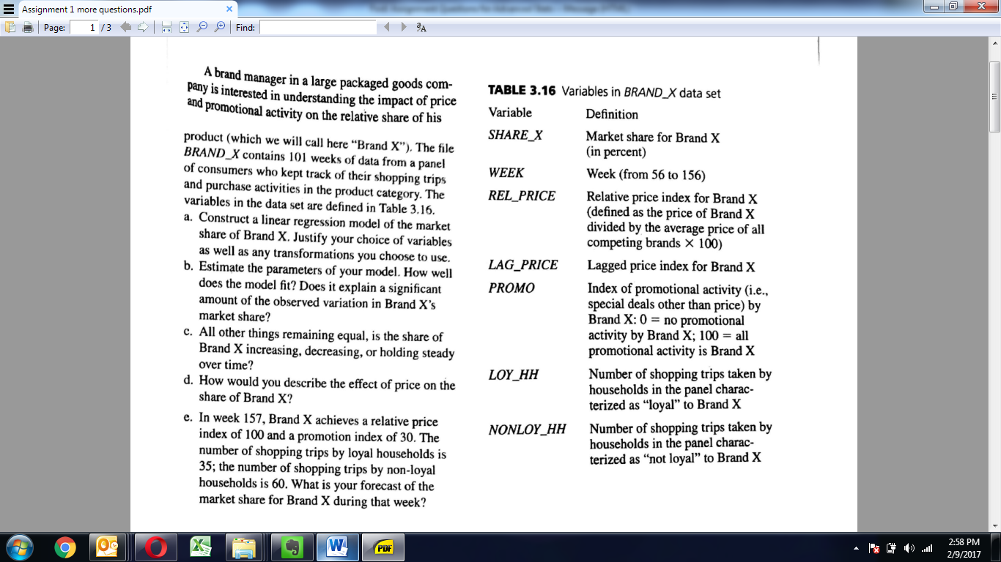

**Question 4**

